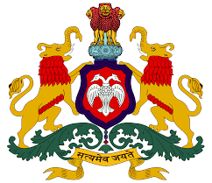
GOVERNMENT TOOL ROOM AND TRAINING CENTRE
(A Scientific & Industrial Research Organization Recognized by Government of India)

A PROJECT REPORT ON
“IMAGE PROCESSING TOOLS PROJECT”
Submitted in partial fulfilment of the curriculum requirements prescribed for the

THIRD SEMESTER OF IMAGE PROCESSING AND NATURAL LANGUAGE PROCESSING
DIPLOMA IN ARTIFICIAL INTELLIGENCE AND MACHINE LEARNING
BY
MR.ATHARVSHETTY(8080110)
MS.NAGAVENIPATIL(8080123)
MR.ADINATHVASULKAR(8080102)
MR.ADITYAGODASE(8080103)

UNDER THE GUIDANCE OF
MR. AMBAPRASAD SIR

GOVERNMENT TOOL ROOM AND TRAINING CENTRE Industrial Estate khanapur road udaymbag,belagavi-590008


ACKNOWLEDGEMENT
I would like to express my sincere gratitude to GTTC Belagavi for providing me with the opportunity and resources to complete this project, “ImagePro Studio – Image Processing Tools.”
I am thankful to my faculty and project mentor for their valuable guidance, continuous support, and encouragement throughout the development of this project.
I would also like to thank the Department of AI & Machine Learning for providing the necessary technical knowledge and laboratory facilities required to successfully complete the project.
Finally, I thank my parents, friends, and classmates for their support and motivation during the development of this project.

Thank You.!!!!!!

INTRODUCTION
ImagePro Studio is a web-based Image Processing Tools application developed using Python, Flask, OpenCV, NumPy, HTML, CSS, and JavaScript. The main purpose of this project is to provide a simple and interactive platform for performing fundamental digital image processing operations.
The application allows users to upload an image from their computer or capture an image using a camera. After selecting an image, users can apply different image processing techniques such as grayscale conversion, binary conversion, RGB to HSV conversion, histogram equalization, brightness and contrast adjustment, average filtering, Gaussian filtering, Laplacian sharpening, Sobel edge detection, and Canny edge detection.
The Flask backend handles the image-processing requests, while OpenCV and NumPy perform the required image operations. The processed image is then displayed to the user, who can preview and download the result in supported formats such as JPG, PNG, and BMP.
The project is mainly developed for educational and academic purposes. It helps students understand the practical implementation of fundamental image processing concepts and demonstrates how Python, OpenCV, and web technologies can be combined to create a useful image-processing application.

OBJECTIVES OF THE PROJECT
- To understand the basic concepts of digital image processing.
- To implement image processing operations using OpenCV.
- To develop a user-friendly web-based image processing application.
- To allow image input through upload and camera capture.
- To perform image enhancement, filtering, color conversion, and edge detection.
- To display and download processed images.
- To demonstrate the practical use of Python, Flask, OpenCV, and NumPy.

TECHNOLOGY USED
The ImagePro Studio project uses the following technologies:
Technology | Purpose
Python | Main programming language
Flask | Develops the web application and handles backend requests
OpenCV | Performs image processing operations
NumPy | Handles image data and numerical operations
HTML5 | Creates the structure of the web pages
CSS3 | Provides styling and layout
JavaScript | Provides interactive features and camera functionality
Web Camera API | Captures images directly from the browser camera
Jinja2 | Connects Flask backend data with HTML templates

Main Technologies
- Frontend: HTML5, CSS3, JavaScript
- Backend: Python, Flask
- Image Processing: OpenCV
- Numerical Processing: NumPy
- Input: Image Upload and Web Camera
- Output: JPG, PNG, and BMP images

ARCHITECTURE DESIGN
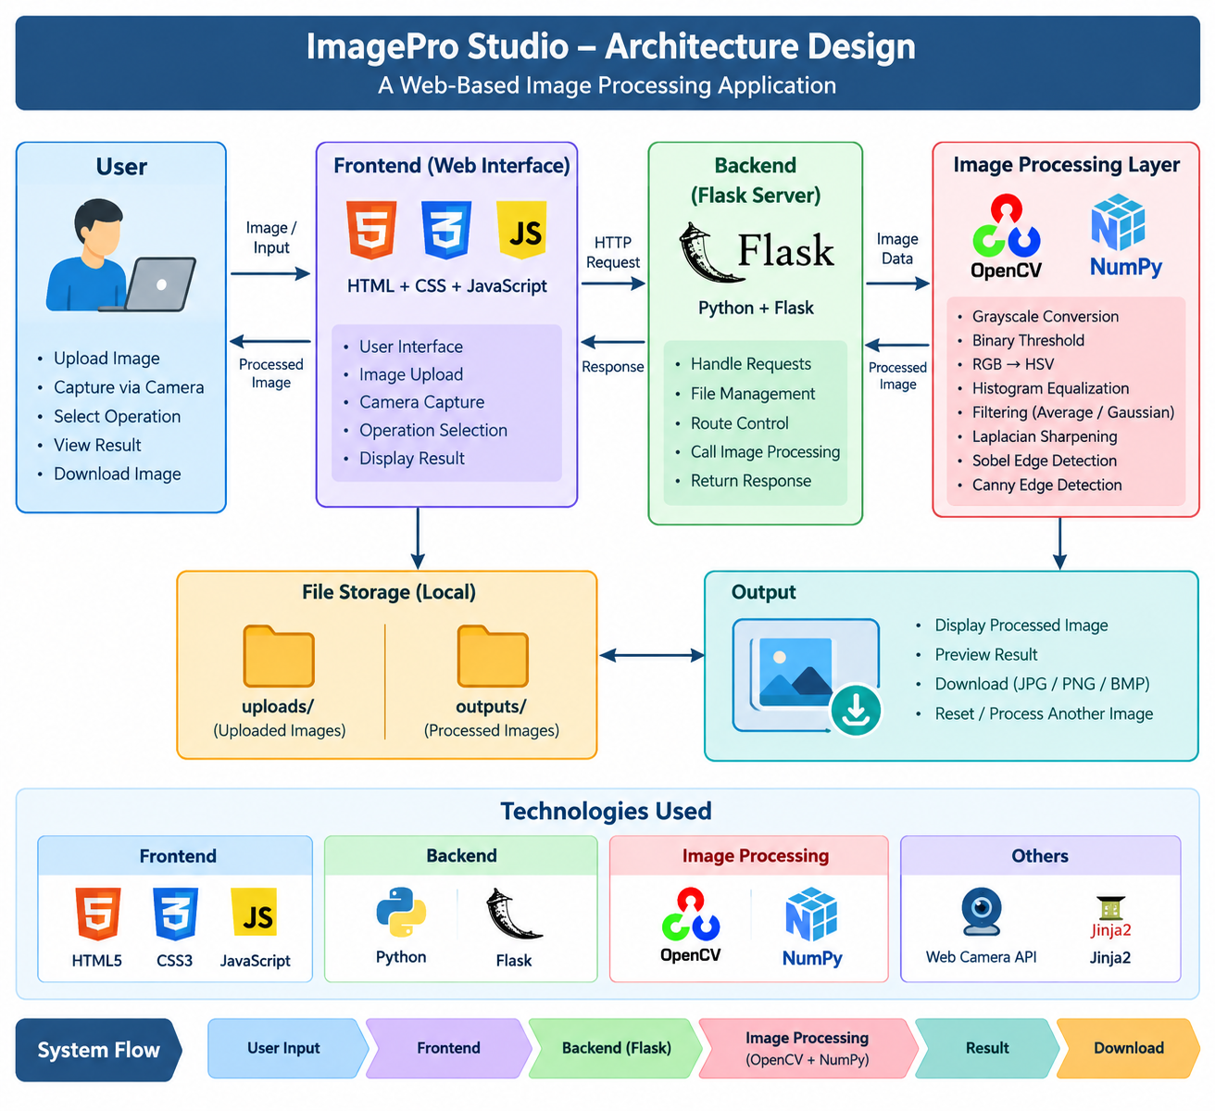
The ImagePro Studio follows a simple three-layer web application architecture consisting of the frontend, backend, and image-processing layer.

WORKING OF THE ARCHITECTURE
- User Input: The user uploads an image or captures an image using the camera.
- Frontend: HTML, CSS and JavaScript provide the user interface and send the image to the Flask server.
- Backend: Flask receives the image and manages the processing request.
- Image Processing: OpenCV and NumPy perform the selected image-processing operation.
- Output: The processed image is returned to the frontend and displayed to the user.
- Download: The user can download the processed image in JPG, PNG, or BMP format.

FILE STRUCTURE
The ImagePro Studio project is organized into the following files and folders:
ImageProStudio_fixed/
│
├── app.py
├── requirements.txt
├── README.md
│
├── templates/
│ └── index.html
│
├── static/
│ ├── style.css
│ └── script.js
│
├── uploads/
│ └── Uploaded images
│
└── outputs/
└── Processed images
IMAGE PROCESSING OPERATIONS

1. Grayscale Conversion
Method: Converts a color image into a grayscale image.
Syntax:
gray = cv2.cvtColor(img, cv2.COLOR_BGR2GRAY)

Output Produced:Grayscale image.
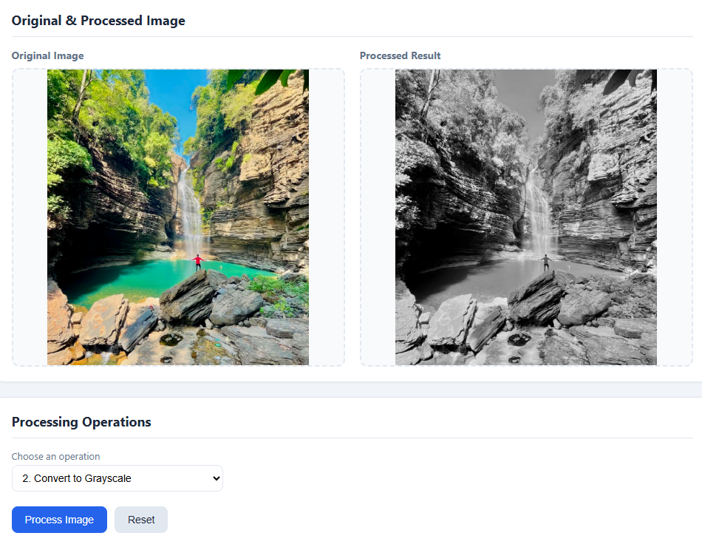

2. Binary Image
Method: Converts a grayscale image into black and white using thresholding.
Syntax:
_, binary = cv2.threshold(gray, 127, 255, cv2.THRESH_BINARY)
Output Produced: Binary black-and-white image.
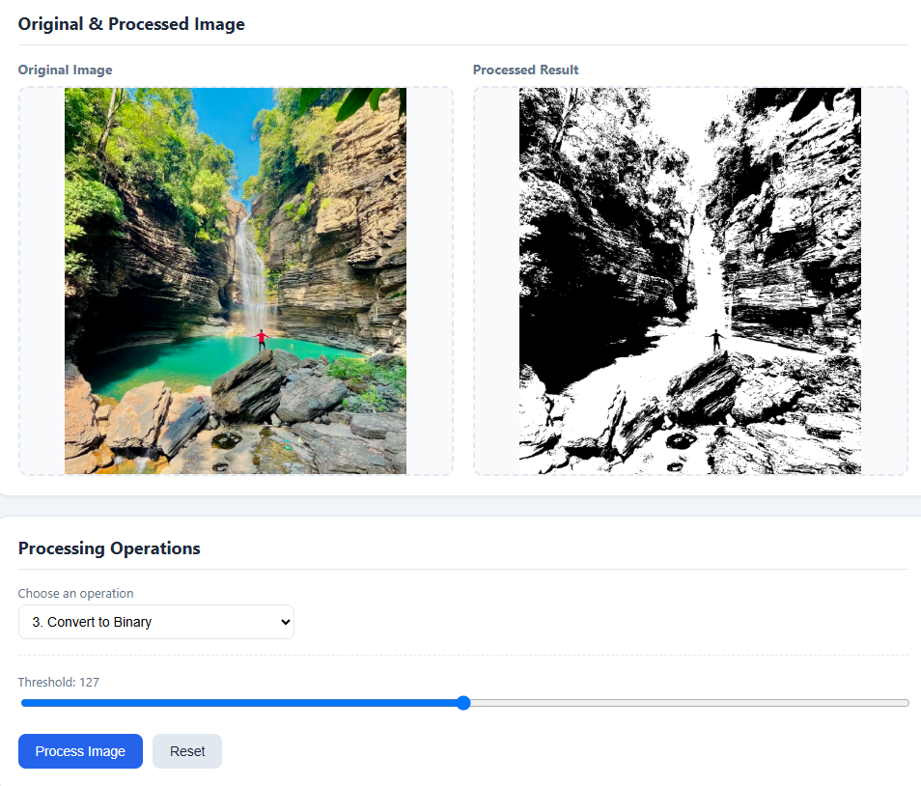

3. RGB to HSV
Method: Converts the image from BGR/RGB color space to HSV color space.
Syntax:
hsv = cv2.cvtColor(img, cv2.COLOR_BGR2HSV)
Output Produced: HSV color image.
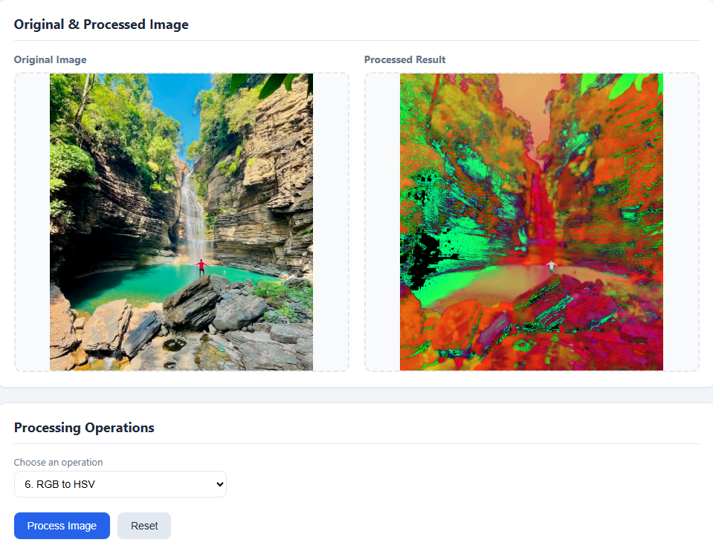

4. Histogram Equalization
Method: Improves the contrast of a grayscale image.
Syntax:
equalized = cv2.equalizeHist(gray)
Output Produced: Contrast-enhanced image.
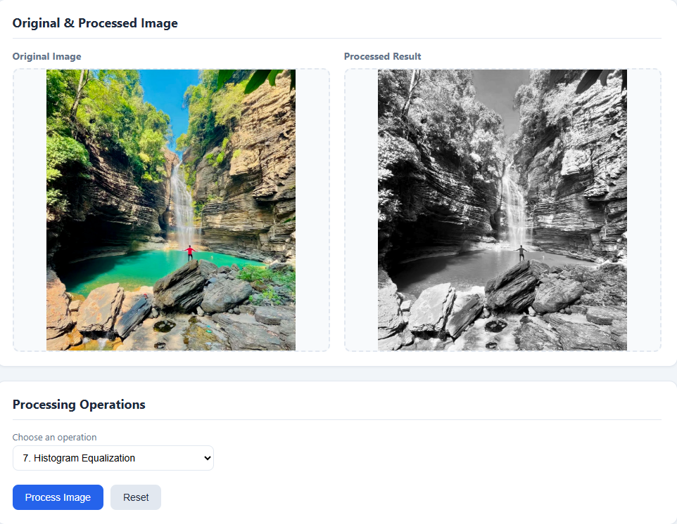

5. Brightness and Contrast Adjustment
Method: Changes the brightness and contrast of an image.
Syntax:
result = cv2.convertScaleAbs(img, alpha=1.2, beta=30)
Output Produced: Image with adjusted brightness and contrast.
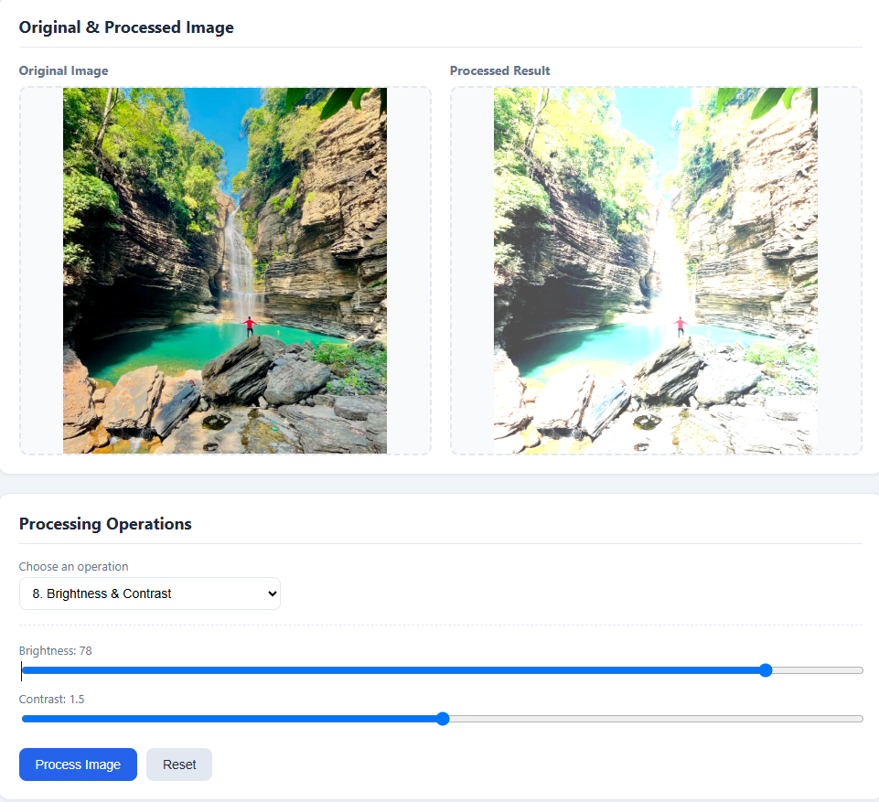

6. Average Filter
Method: Smooths the image by averaging neighboring pixels.
Syntax:
result = cv2.blur(img, (5, 5))
Output Produced: Smoothed/noise-reduced image.
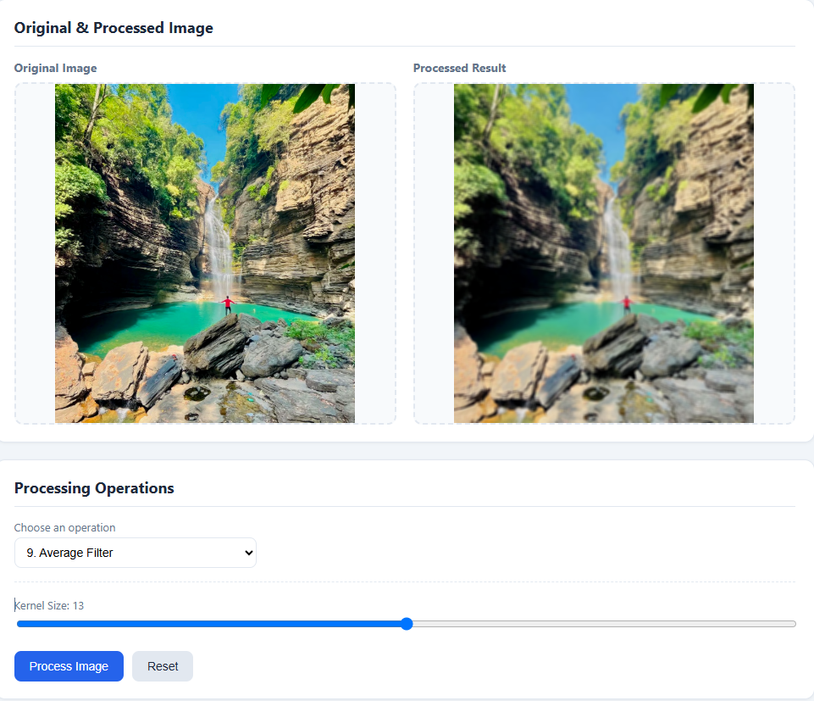

7. Gaussian Filter
Method: Smooths the image using a Gaussian kernel.
Syntax:
result = cv2.GaussianBlur(img, (5, 5), 0)
Output Produced: Smooth and noise-reduced image.
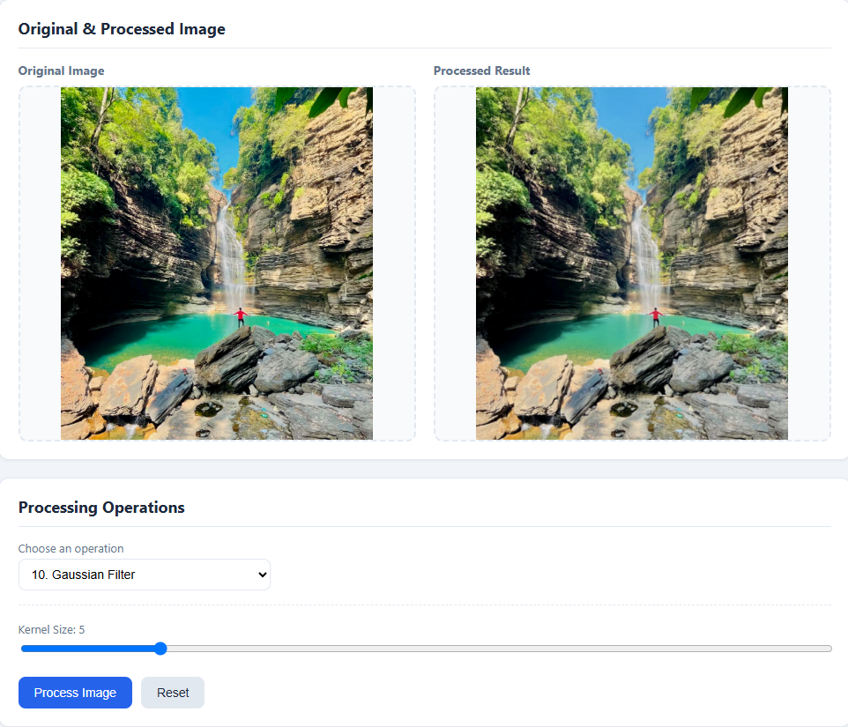

8. Laplacian Sharpening
Method: Enhances edges and fine details in an image.
Syntax:
laplacian = cv2.Laplacian(img, cv2.CV_64F)
Output Produced: Edge-enhanced/sharpened image.
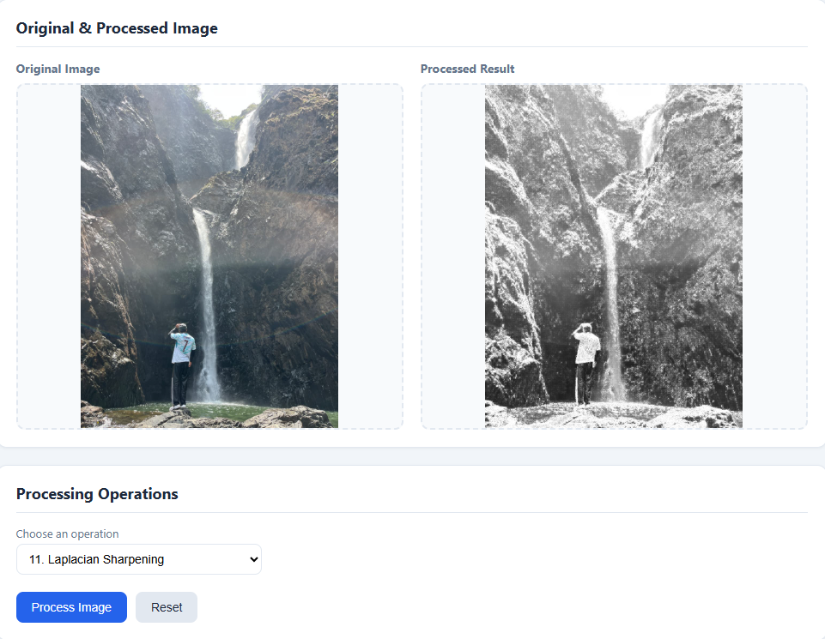

9. Sobel Edge Detection
Method: Detects edges in horizontal or vertical directions.
Syntax:
sobelx = cv2.Sobel(gray, cv2.CV_64F, 1, 0, ksize=3)
sobely = cv2.Sobel(gray, cv2.CV_64F, 0, 1, ksize=3)
Output Produced: Image showing detected edges.
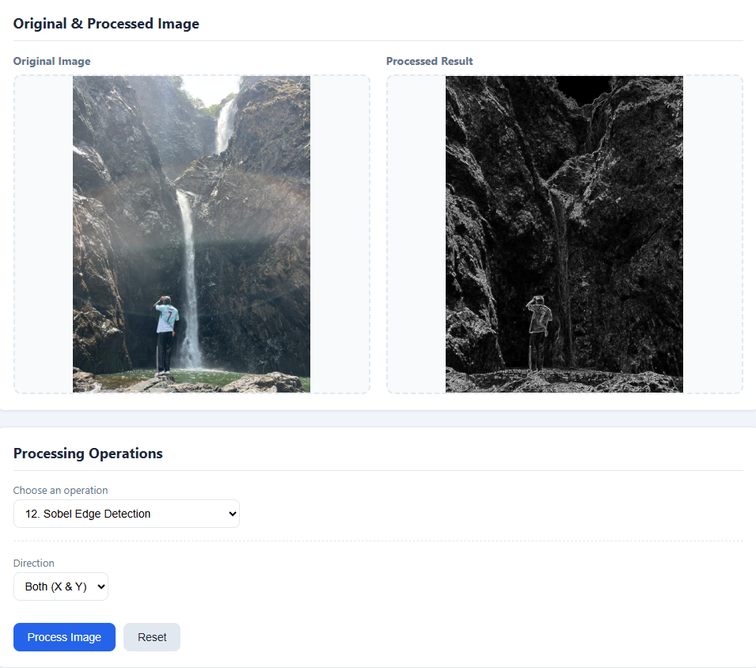

10. Canny Edge Detection
Method: Detects strong and important edges in an image.
Syntax:
edges = cv2.Canny(gray, 100, 200)
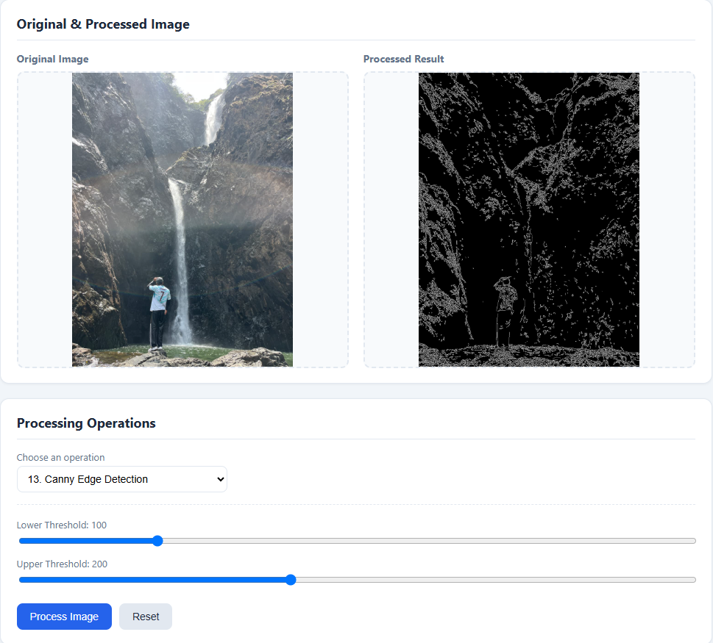
Output Produced: Binary edge-detected image.

CONCLUSION
The ImagePro Studio – Image Processing Tools project successfully provides a simple and user-friendly web-based platform for performing basic image processing operations. The application combines Python, Flask, OpenCV, NumPy, HTML, CSS, and JavaScript to process images efficiently.
The system allows users to upload images or capture images using a camera, apply various processing techniques such as grayscale, binary thresholding, color conversion, histogram equalization, filtering, sharpening, and edge detection, and view the processed results.
This project helped in understanding the practical implementation of digital image processing concepts and demonstrated how image-processing techniques can be integrated into a web application. Overall, ImagePro Studio is a useful educational project for learning and demonstrating fundamental image processing operations using OpenCV.

----ATHARV SHETTY
FINAL YEAR DAIML 5TH SEM

